- Execute the grep commands to search for patterns in the file f2

- cat f2 [ To view the content of f2 ]
- grep good f2 [ To display all lines containing the pattern “good” ]
- grep -w good f2 [ To match only the whole word “good”, excluding words like “goodmorning” ]

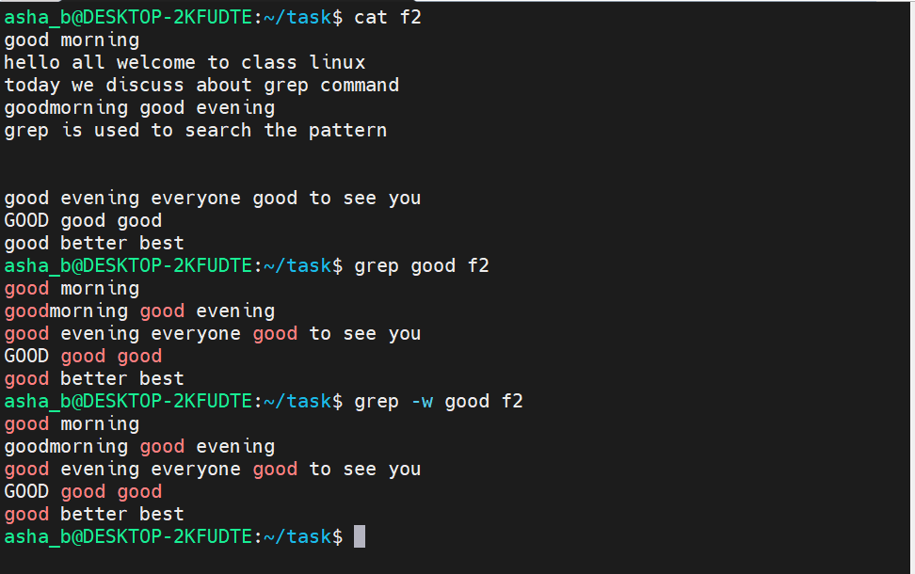

- grep -o good f2 [ To print only the matched text “good” instead of the whole line ]
- grep -o "good evening" f2 [ To print only the matched phrase “good evening” ]
- grep -o "good morning" f2 [ To print only the matched phrase “good morning” ]
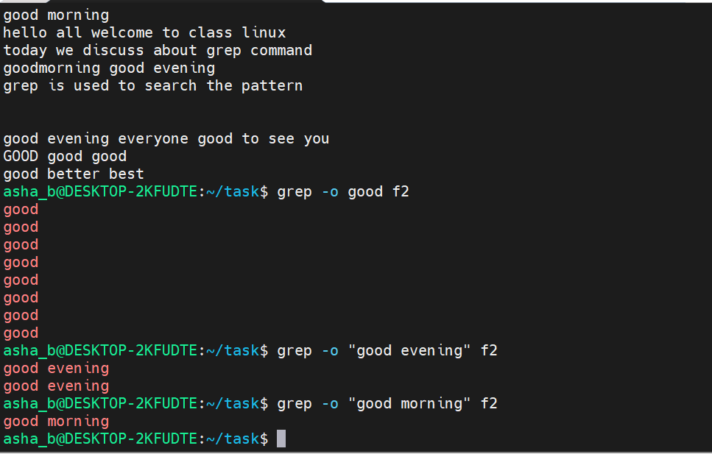

- grep -i good f2 [ To search for “good” case-insensitively, matching “GOOD” as well ]
- grep -v good f2 [ To display only the lines that do NOT contain “good” ]

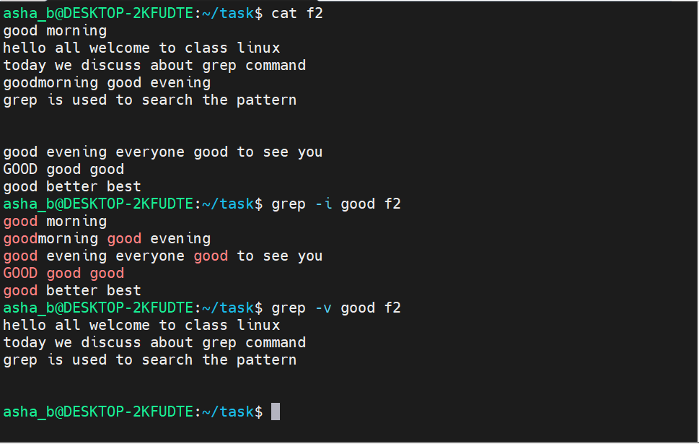
- grep -c good f2 [ To count the number of lines containing “good” ]
- grep -c evening f2 [ To count the number of lines containing “evening” ]
- grep -c "good morning" f2 [ To count the number of lines containing “good morning” ]

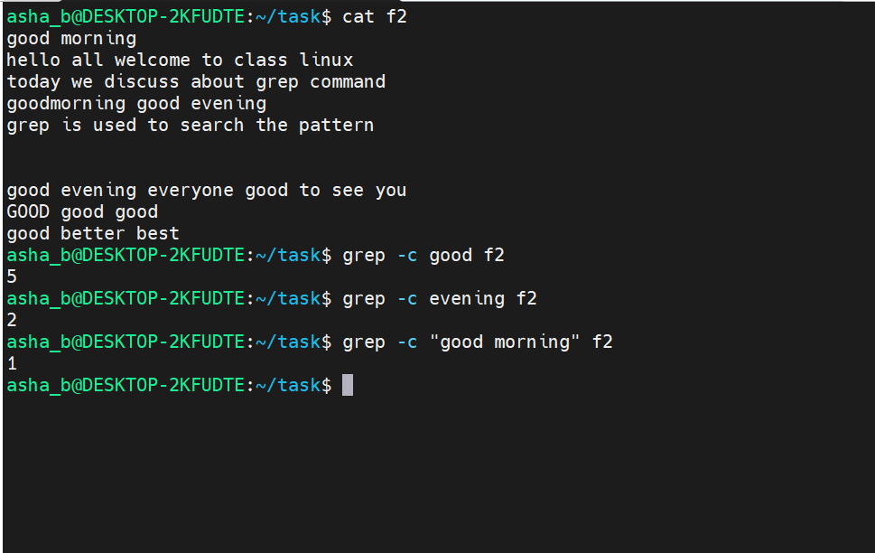

- cat -n f2 [ To view the content of f2 with line numbers ]
- grep -n good f2 [ To display matching lines along with their line numbers ]
- grep -n "good " f2 [ To display line numbers for lines containing “good” followed by a space ]

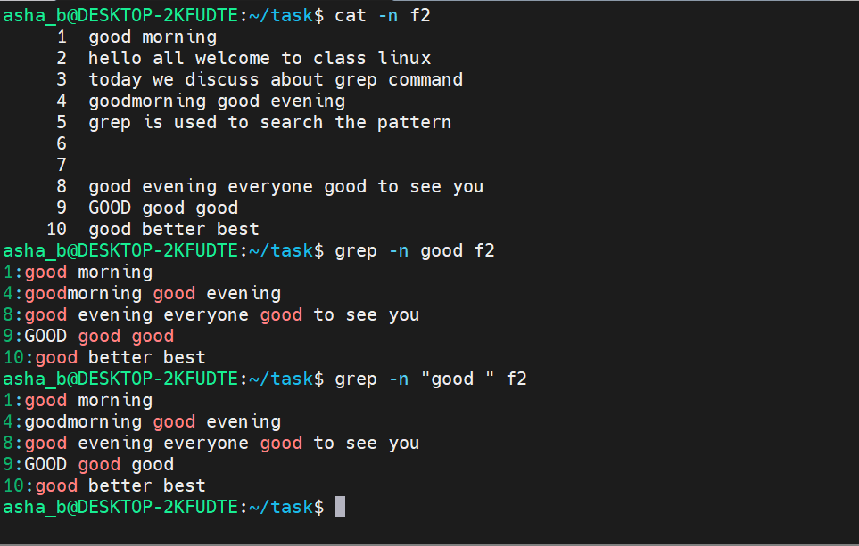

- grep -n -i good f2 [ To combine line numbers with a case-insensitive search ]
- grep -n -v good f2 [ To display line numbers for lines that do NOT contain “good” ]
- grep -n -o GOOD f2 [ To display the line number and only the exact matched text “GOOD” ]

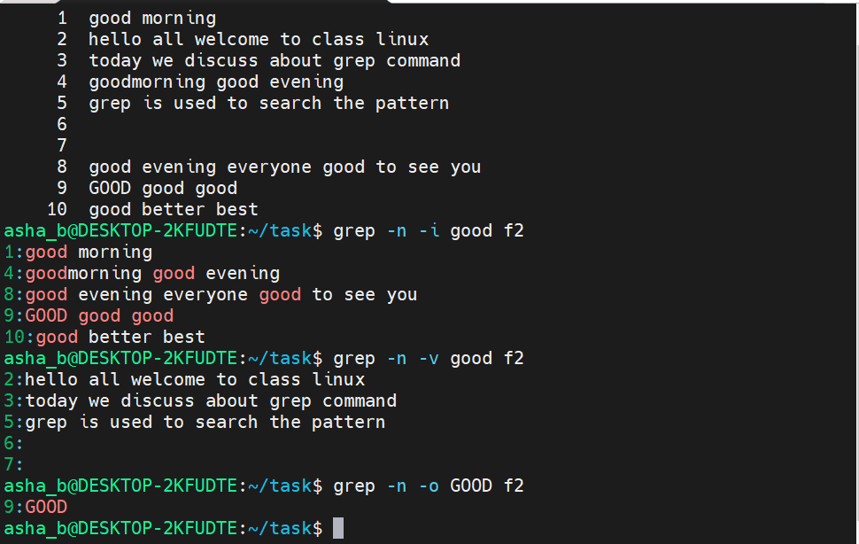

- grep -o -n "good evening" f2 [ To display the line number and only the matched phrase “good evening” ]
- grep -w -n "good evening" f2 [ To match the whole phrase “good evening” as a word, with line numbers ]
- grep -n -o -i good f2 [ To combine line numbers, matched-text-only output and case-insensitive search ]
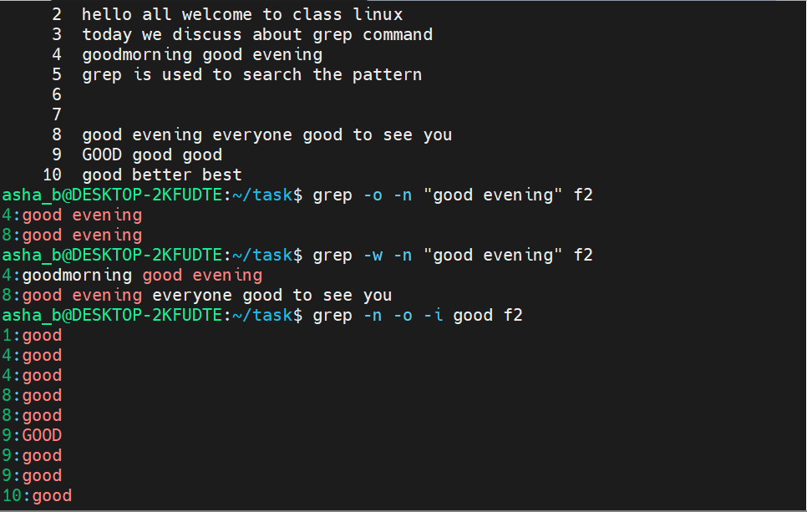

- grep "goodmorning" f2 [ To search for the exact single word “goodmorning” ]
- grep -e "goodmorning" -e "grep" -e "good evening" f2 [ To search for multiple patterns in a single command using -e ]

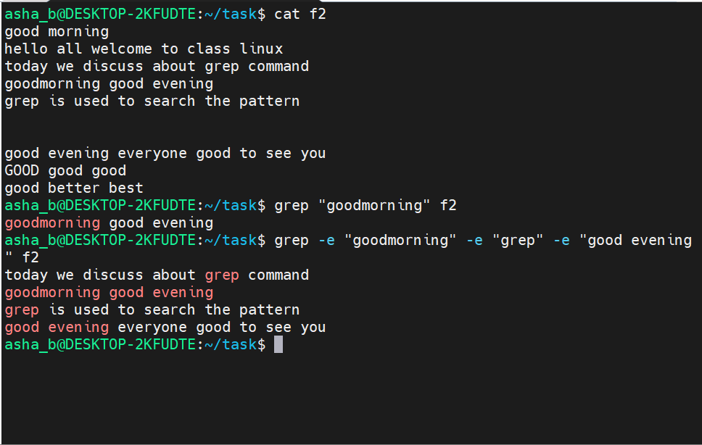
- Execute the awk commands to process and extract fields from the file f2

- awk '{print}' f2 [ To print every line of f2, same as cat ]
- awk '{print $2}' f2 [ To print only the second field (word) of every line ]

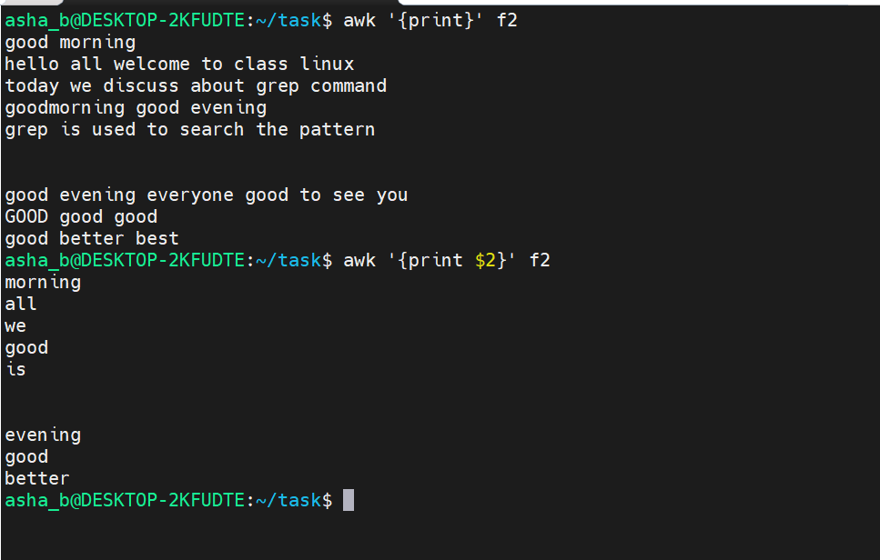

- awk '{print $2,$5}' f2 [ To print the second and fifth fields of every line ]

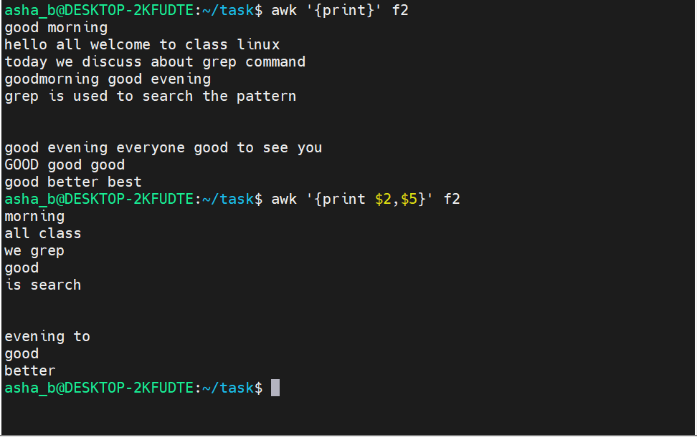
- awk '{print NF,$3}' f2 [ To print the number of fields (NF) and the third field of every line ]

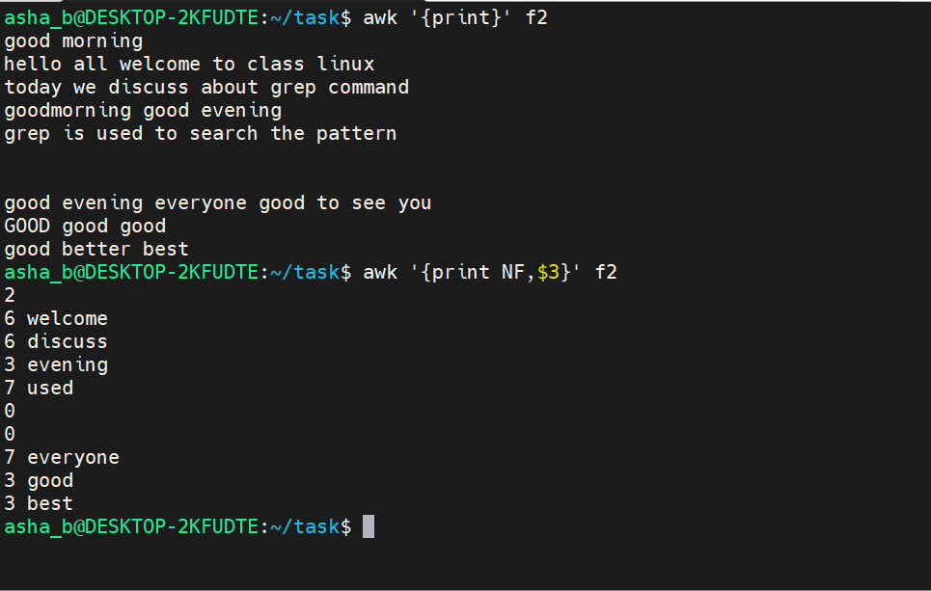

- awk '{print NF,$0}' f2 [ To print the number of fields followed by the entire line ($0) ]

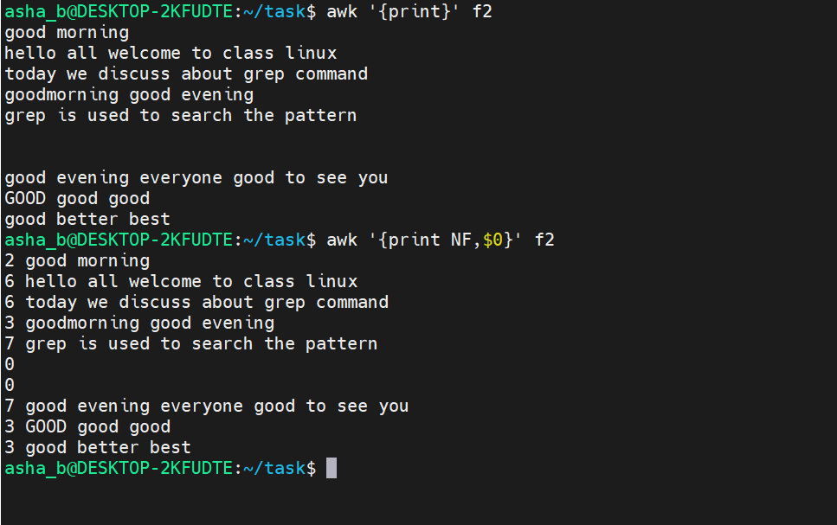
- awk '{print NF}' f2 [ To print only the number of fields (words) in every line ]
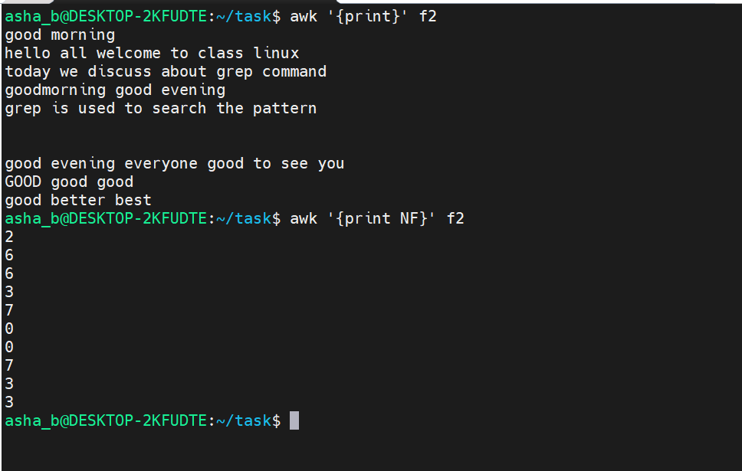

- awk '{print NR,$2}' f2 [ To print the row/line number (NR) followed by the second field ]

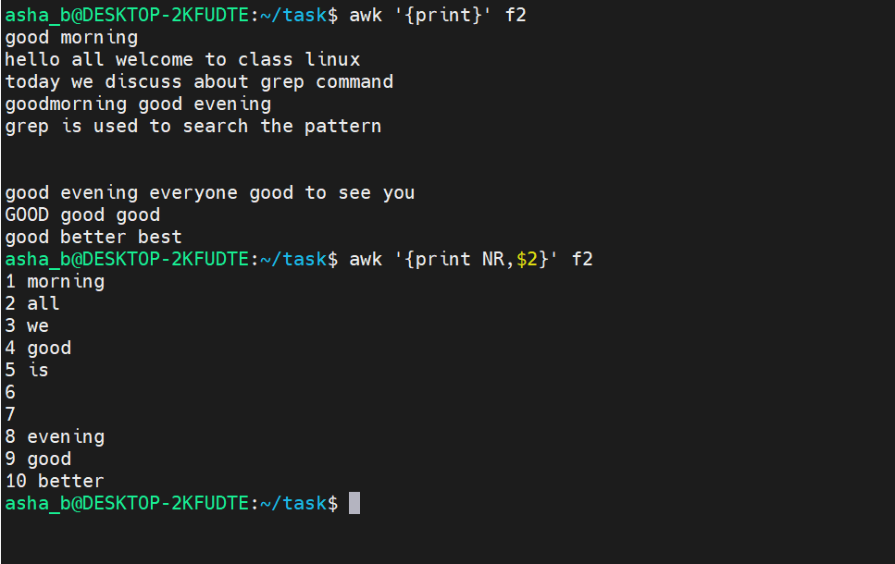
- awk '{print NR,$0}' f2 [ To print the line number followed by the entire line ]
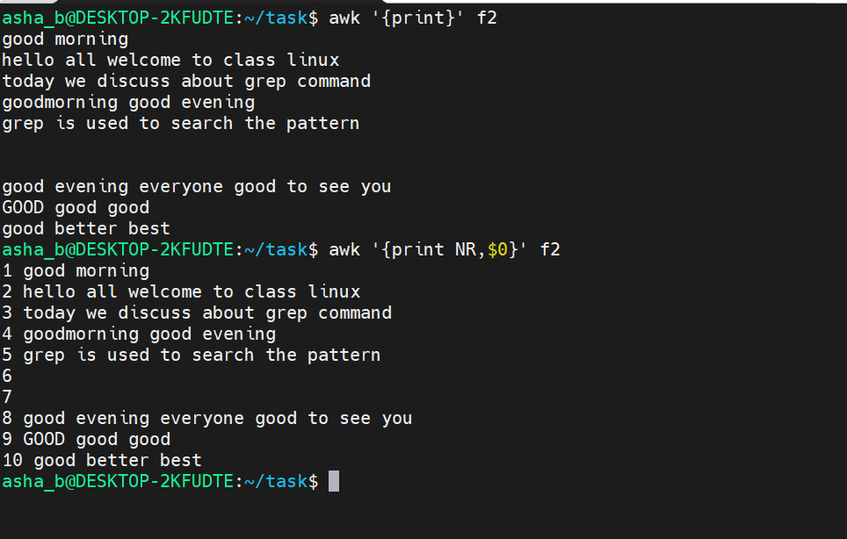

- awk 'END{print NR}' f2 [ To print the total number of lines in f2 ]
- awk 'NF>0{print $2}' f2 [ To print the second field only for non-blank lines, skipping empty lines ]

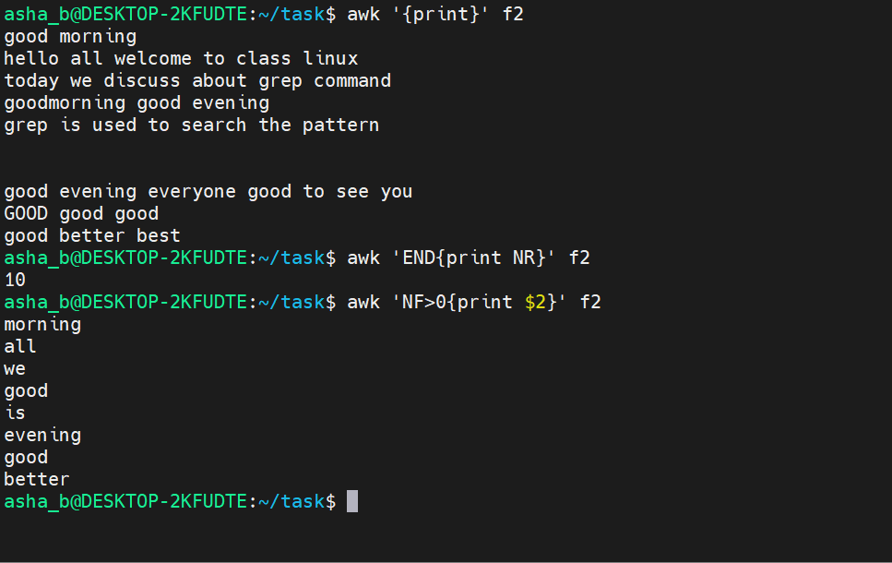
- awk 'NF>5{print NF,NR,$7}' f2 [ To print NF, NR and the seventh field, only for lines with more than 5 fields ]
- awk 'NR>6{print NR,NF,$3}' f2 [ To print NR, NF and the third field, only for lines after line 6 ]

